Hullbreaker

Break them apart!

# Table of Contents

Contents

Table of Contents 2

Declaration 4

1. Introduction 4

1.1. Concept 4

1.2. Feature Set 5

1.3. Genre(s) 5

1.4. Target Audience 5

1.5. Game Flow 5

1.6. Look and Feel 6

1.7. Scope 6

1.7.1 Complexity 6

1.7.2 Novelty 7

1.7.3 Breadth 7

2. Investigation of Project Idea 8

2.1 Literature Review 8

2.1.1 Procedural Generation 8

2.1.2 Dynamic Difficulty 9

2.1.3 Turn Based Combat 10

2.2. Feasibility 10

2.2.1. Market 10

2.2.2. Similar Products 10

2.2.3. Unique Selling Points 12

2.3. Technical Investigation 12

2.3.1. Target hardware for Deployment 12

2.3.2. Development hardware and software 13

2.3.3. Game Engine 13

2.3.4. Scripting Language 13

3. Project Management 13

3.1. Project Methodology 13

3.2. Detailed Schedule 14

3.3. Schedule Management 15

3.4. Version Control 15

3.5. Risk Analysis 15

3.6. Test Plan 16

4. Project Design 16

4.1. Gameplay 16

4.1.1. Game Progression 16

4.1.2. Mission/Challenge Structure 17

4.1.3. Objectives 17

4.1.4. Play Flow 17

4.2. Mechanics 17

4.2.1. Navigation 17

4.2.2. Encounters and Events 18

4.2.3. Factions 19

4.2.4. Turn-Based Combat 20

4.3. Screen Flow 21

4.3.1. Description of Game Screens 22

4.4. Game Options 25

4.5. Replaying and Saving 25

4.6. Story and Narrative 25

4.6.1 Backstory 25

4.6.2 Plot Elements 26

4.6.3 Game Progression 27

4.6.4 Cut Scenes 27

4.7. Game World 28

4.7.1. General Look and Feel of The World 28

4.7.2. Areas 28

4.8. Characters 29

4.8.1 Character #1 – Joe Aveg 29

4.8.2 Character #2 – Johny Raats 31

4.9. Levels 33

4.9.1. Overview 33

4.9.2. Beat Chart 33

4.9.3 Level #1 – The Heap 34

4.9.4 Level #2 – The Planes 35

4.9.5 Level #3 – The Beyond 36

4.10. Interface 37

4.10.1. Visual System 37

4.10.2. Control System 38

4.10.3. Audio 39

4.10.4. Help System 40

4.11. Artificial Intelligence 40

4.12. Game Art 40

4.12.1 Concept Art 40

5. Appendices 47

5.1. Credits 47

5.2. References 48

# Declaration

I certify that this assignment is all my own work and contains no plagiarism. By submitting this assignment, I agree to the following terms:

Any text, diagrams or other material copied from other sources (including, but not limited to, books, journals, and the internet) have been clearly acknowledged and referenced as such in the text by the use of ‘quotation marks’ (or indented italics for longer quotations) followed by the author’s name and date [e.g. (Byrne, 2008)] either in the text or in a footnote/endnote. These details are then confirmed by a fuller reference in the bibliography.

I have read the sections on referencing and plagiarism in the handbook or in the SETU Plagiarism policy and I understand that only assignments which are free of plagiarism will be awarded marks. I further understand that SETU has a plagiarism policy which can lead to the suspension or permanent expulsion of students in serious cases.

Signed: Anthony O’Keeffe

Dated: 01/01/2024

# 1. Introduction

## 1.1. Concept

HullBreaker is a 2D roguelike* game with mechanics inspired by turn-based RPGs** and card battler games***. The game is set in a galaxy in the far future where resources have become so tight that a ship salvaging company by the name of “HullBreakers Inc.” holds most of the power across the system.

One day the company suddenly announces that all operations are to stop, all employees are to be fired and all company machines are shutdown. The now alienated ex-employees of HullBreakers Inc are all left furious at their bosses’ decision to abandon them all and so each one seeks revenge on their prior employers.

* Roguelike are games characterised by their use of procedural generation, permanent death and focus on replayability.

** Turn-Based Role-Playing Games are games which mainly have a focus on the player character and the in-game combat which consists of the player turn and then the enemy turn.

*** Card Battlers are games which are inspired by the Turn-Based RPG genre but have greater focus on adaptive strategy using deck building and unlockable upgrades.

## 1.2. Feature Set

* Various playable characters.
* Many ships and pilots to find, purchase and recruit.
* Dozens of enemies and events to encounter.
* Procedural map generation so every run feels varied.
* Dynamic Difficulty. If the player becomes too strong the game will become more difficult to accommodate.
* A unique combat system which blends aspects from the card battler and RPG genre.

## 1.3. Genre(s)

Roguelike, 2D, Strategy, Procedural Generation*, RPG, Replay Value, Single player, Roguelite**, Sci-Fi, Fantasy, Casual

* Procedural generation is where data or aspects of a game is generated using a set of restrictions.

** A Roguelite game is a game that follows some aspects of what makes a roguelike game but strays away or diversifies in other areas.

## 1.4. Target Audience

The target audience of HullBreaker is players who want a unique roguelike experience. The game aims to pull away from aspects of other roguelikes that have become popular in recent years in exchange for a new spin on and exploration of how progression through a roguelike game can be done. These changes to the established formula aim to draw in players who seek a fresh and more strategic style of play.

## 1.5. Game Flow

HullBreakers game flow is open and mostly decided by the player. The games semi open world map offers players several options for how fast they wish to progress through the games content. However, the player is required to defeat an area boss to progress further outwards in the world map. Once the player defeats the third and final boss on the other edges of the map, they win that run. The player will have a plethora of options, ships and encounters that can either help or hinder this goal along the way.

## 1.6. Look and Feel

HullBreaker is set in a galaxy in the far-off future. Within this galaxy resources have become sparce and many factions have been formed, each with their own means of getting by. Most planets in this galaxy have been industrialized by HullBreakers Inc. and now every world that harbours intelligent life are overrun by towering complex infrastructure. Each planets faction has their own unique look and feel from the Enforcers cold and brutalist barracks to the Cultists towering, dogmatic churches of scrap metal.

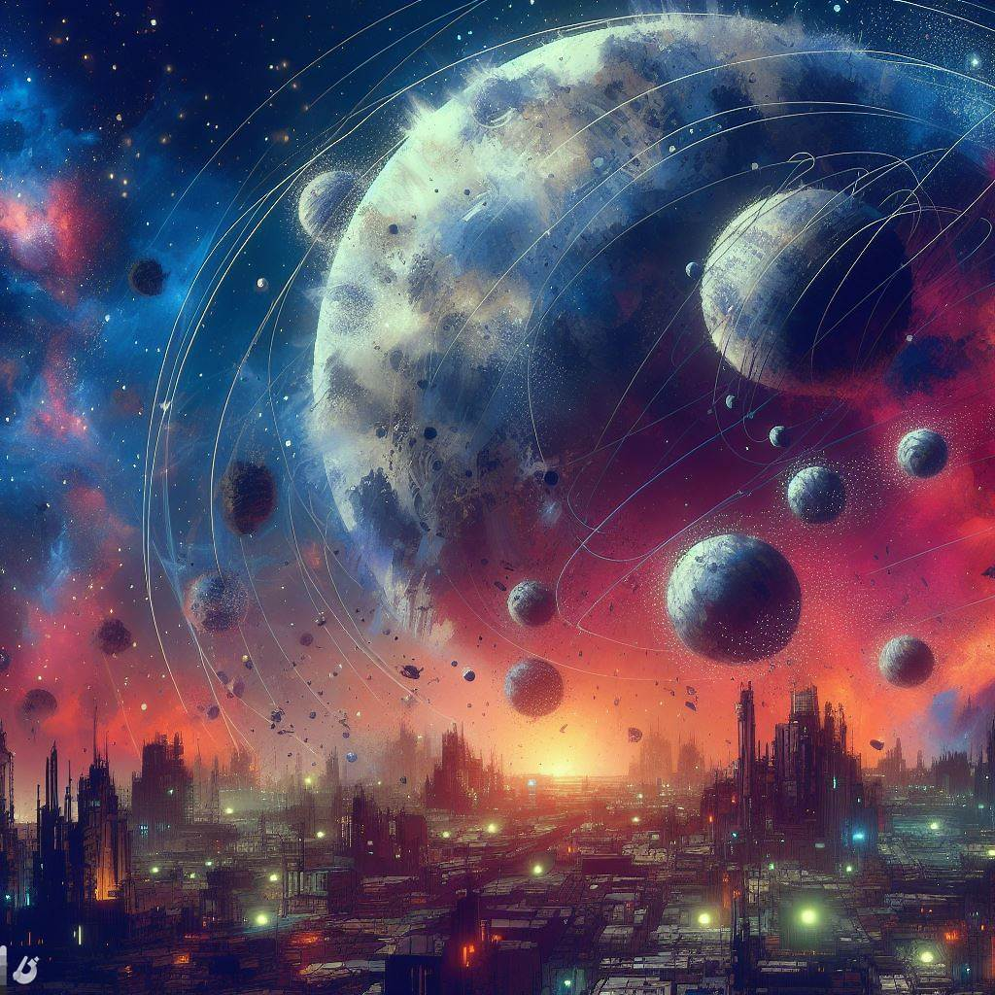HullBreaker presents this imagery through its simple 2D pixel art style.

Figure 2 - Concept of Industrial Planets, Dall E 3 (2023)

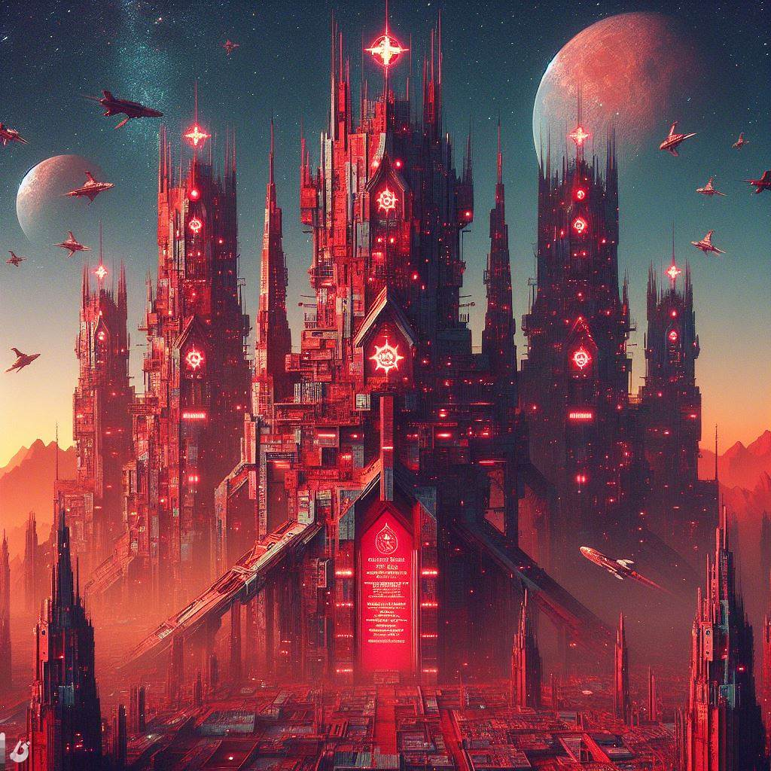

Figure 1 - Concept of Cultist Church, Dall E 3 (2023)

## 1.7. Scope

### 1.7.1 Complexity

HullBreaker will feature various complex mechanics such as:

* Procedurally generated solar systems which will contain many unique and generated planets and events to keep the game feeling new and to increase replayability.
* Dynamically scaling difficulty that adapts to how far the player has progressed and how well they are doing to give a more challenging and engaging experience.
* A unique combat system inspired by turn-based RPG where the player can recruit various ships and pilots to their side with their own array of benefits, abilities and actions.
* Unlockable ships and characters that are gained at the end of each playthrough of the game to give the player more incentive to replay and experiment with new unlocked components of the game.

### 1.7.2 Novelty

HullBreaker will do two things differently from standard roguelikes, feature a unique combat system based on classic RPGs and having an open world navigation map free for the player to traverse fully.

HullBreakers combat system is one not commonly seen in roguelike genre. It sees the player collecting various ships and pilots to match together and get unique action and ability combinations. This is to give players a unique experience every time they load up the game and take a shot at beating a playthrough.

Open world navigation is also a mechanic not commonly seen in roguelike games. Many roguelikes follow a linear stage progression system, but HullBreaker makes use of a single large scale, procedurally generated map that allows the player to freely explore previously visited routes and conquer all encounters in each zone before progressing.

### 1.7.3 Breadth

HullBreaker will feature three areas the player can traverse in the large world map, The Inner System, The Middle System and The Outer System. Each area will have a variety of encounters the player may come across such as enemy ships, broken vessels, random events, and an area boss which must be defeated before the player can travel to further areas.

HullBreakers unique combat mechanics offer players a new refreshing way to engage in combat which takes inspiration from classic RPGs like *Final Fantasy* (Square Enix, 1987) and *Earthbound* (Nintendo, 1994). Mechanics of this combat system include but are not limited to:

* Pilots that provide passive effects and buffs.
* An upgrading energy system.
* Ships which provide various actions the player can take during their turn.

The actions that the player will be using during combat also have a multitude of effects including ones such as:

* Dealing damage.
* Blocking damage.
* Healing.
* Shielding from damage.
* Buffing and Debuffing*.
* And many more.

While navigating the game world the player can also encounter areas such as shops for upgrades, random events, enemies, mini bosses and area bosses. This world the player navigates is a large solar system map split up into three concentric ring areas which make up the world of HullBreaker.

When defeating enemies, the player will be given the option to salvage there fallen enemies ship to acquire additional upgrades for themselves. The quality of these upgrades varies from enemy to enemy and area to area with mini bosses providing stronger upgrades and area bosses providing an artifact, strong single time attainable powerups.

* A Debuff in games is a negative effect that can be applied to enemies and players. Examples of a debuff include reducing damage dealt or increasing damage received.

# 2. Investigation of Project Idea

## 2.1 Literature Review

### 2.1.1 Procedural Generation

Procedural Generation, in simple terms, is the creation of data by computers. This data can be theoretically anything but where procedural generation is most used is the creation of content for video games and various media. Procedural generation is most used for the creation of content and assets which possesses random elements or would be tedious to create manually. In the modern-day procedural generation is mostly associated with the generation of maps and terrain in games such as Minecraft (Mojang, 2011) and Terraria (Re-Logic, 2011). It is also heavily associated with the roguelike genre of games, having become a core aspect of the genre over the past four decades with some of the first games of the genre making use of procedural generation for level generation, the most notable of which being *Rogue* (Akeley, 1980) the early 1980’s dungeon crawler known for inspiring the genre.

There are many benefits to generating the levels / stages of a game procedurally with some of the most prominent being added replay value, not needing to spend development time on level design and reduced memory usage. The arguably greatest benefit of the above listed is the added replay value. Having a games stage be randomly generated means the player is all but guaranteed to never see the same stage twice. This does wonders for keeping games fresh and when combined with an equally enthralling game play loop can lead to creating a near endless experience for the player.

On the opposite side of this spectrum however lies the downsides of procedural generation with the most notable of them being increased randomness, difficulty adding scripted events and it being more taxing on hardware. All though adding randomness to a game can increase its replay value it can also act as great detriment towards the balance of the game. The generation could cause scenarios where the player is unable to progress or even miss important events. Methods of procedural generation that construct levels from the ground up using certain data tend to appear disorganized and disorderly (Gellel and Sweetser, 2020). A game that demonstrates the rights and wrongs of procedural generation would be *Risk of Rain* (Hopoo Games, 2013)

*Risk of Rain* (Hopoo Games, 2013) is a roguelike where the stages the player must progress are procedurally generated, with treasure and the exit being randomly place across the stage. The game is praised for its addictive gameplay and difficulty, but it has also seen its fair share of detraction due to how the generation of its treasure and, most importantly, stage exits can at times be inaccessible. This makes the game somewhat of a balancing nightmare due to its heavy utilization of procedural generation, sometimes causing the player to receive an overwhelming number of items by the end of the first stage or to get close to none on subsequent playthroughs. This proves that too much variance can be a detriment to games that wish to incorporate procedural generation. The developers of *Risk of Rain* (Hopoo Games, 2013) did correct this issue in the sequel Risk of Rain 2 (Hopoo Games, 2019) by reducing what areas of stages could be procedurally generated, guaranteeing a minimum number of treasure chest that can spawn on each stage and by limiting the positions the stage exit could spawn on to only several positions on the stage that player is assured to reach.

This style of procedural generation with limits works wonders by still allowing the game to be varied while not causing situations in which the game is unbeatable.

HullBreaker will use this limited procedural generation to create the navigation system for the stages of the game as it will help to create the addictive gameplay loop desired for the game and assist in retaining control of game balance.

### 2.1.2 Dynamic Difficulty

Dynamic Difficulty is the process of adjusting the various behaviours and stats in a game based on the performance of the player. These adjustments can be as simple as increasing enemy health and speed to addition of completely new enemies and scenarios depending on how well the player is performing. The players performance can be judged off several different statistics and many games have taken various approaches to this (Sepulveda, Besoain and Barriga, 2020). Some examples statistics that can be indicative of how challenged the player can be by the game include:

* How much the health the player has lost.
* The players average damage dealt to enemies.
* The time it takes the player to overcome and encounter.
* The number of ships and upgrades a player has.

Etc.

One or more of these above statistics can be allocated a score and then various enemy or world properties can be increased, or even potentially decreased, proportionally to that score. This is excellent way of adding additional challenge to a game and even potentially works to let new players ease into the game if enemies become slightly weaker if they do not perform well.

This way of measuring difficulty can cause issues if not enough data is taken in to determine how well a player is doing. An example of this would be the dynamic difficulty in racing game *Mario Cart* (Nintendo, 1992). The further a player is to first place in *Mario Cart* (Nintendo, 1992) the lower quality of items they will receive, with first place only being able to obtain two types of items. This form of single facetted difficulty scaling encourages a style of play where the player may choose to intentionally slow down to increase the quality of the items they receive. This can be in a positive and negative light as it is a form of strategic play, but it is also abusing the games dynamic difficulty to give the player an advantage they otherwise would not have. This usage of dynamic difficulty has also been dubbed the rubber band effect (Compton, 2019).

2.1.3 Turn Based Combat

Turn based combat is a commonly used form of combat in games and has used been for years, with the first successful electronic implementation of it being in the 1981 Atari release *Eastern Front (1941)* (Atari, 1981).

The main characteristics of genre are:

* The separation of the Player turns and the Enemy turn.
* The freedom of decision time given to the player.
* The emphasis put on strategy and choice.

Although these turn-based systems are often considered to be the “grandfather” of many game genres, especially the turn-based RPG genre, they are often met with several challenges when it comes to implementing them into modern games. Many sources have referred to the genre as a dying medium (Mateen E., 2018) and have said that for modern players to fully enjoy the genre something extra has to be offered.

A game that is often said to have done this masterfully is *Persona 5* (Atlus, 2016). Persona 5 is praised as a quintessential modern-day RPG with addictive gameplay, especially in its turn-based combat. Persona 5 makes use of a “one more” system, which adds variety and excitement to the combat, making it both easy to learn and engaging. Persona 5 also stresses the importance of providing downtime between fights as it contributes to keeping the combat fresh and interesting (Mateen E., 2018).

## 2.2. Feasibility

### 2.2.1. Market

In past few years roguelike games have skyrocketed in popularity. In the year 2023 alone, 1211 games with the roguelike tag were released on Steam (SteamDB, n.d.). The game *Slay The Spire* (MegaCrit, 2017) has sold over 1.5 million copies since its early access launch in late 2017 (McAloon, 2019). Games such as *Risk of Rain 2* (Hopoo Games, 2019) have estimated net revenue of over 58 million dollars in its release lifetime (Steam Revenue Calculator, n.d.).

### 2.2.2. Similar Products

The roguelike game genre is very diverse and boasts a large amount of very popular games. The games which this project draws most inspiration from is *Risk of Rain* (Hopoo Games, 2013) and *Slay The Spire* (MegaCrit, 2017).

Slay The Spire is a rogue-like deck-building game developed by MegaCrit. Released in 2017, the game combines elements of the roguelike genre and traditional deck building games. The unique aspect of *Slay The Spire* lies in its deck-building mechanics, allowing players to strategically choose and upgrade their cards during each playthrough. With a variety of character classes, relics, and constantly evolving challenges, the game offers a highly replayable experience, challenging players to devise new strategies and adapt to the ever-shifting dynamics of the game.

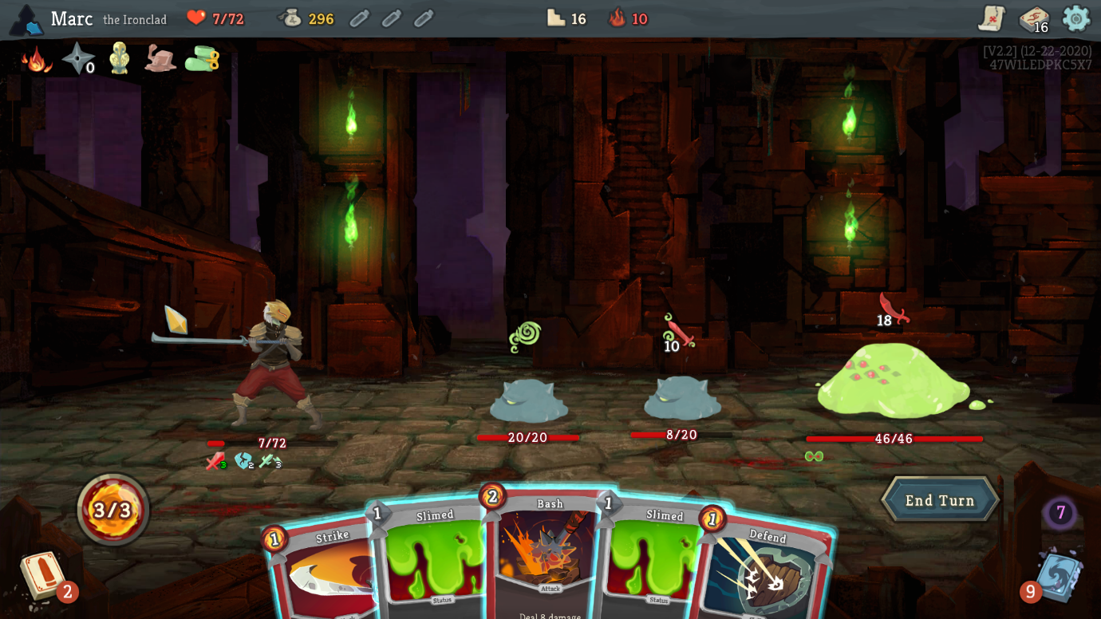

Figure 1 - Slay the Spire Gameplay

Risk of Rain, developed by Hopoo Games and released in 2013, is a multiplayer rogue-like platformer that marries intense action with relentless difficulty. Set on a mysterious alien planet, players navigate procedurally generated levels while battling hordes of hostile creatures. What sets Risk of Rain apart is its time-based difficulty progression – as time elapses, the game becomes progressively harder, demanding swift and strategic gameplay. With a diverse array of playable characters, each possessing unique abilities and skills, players must cooperate to survive the increasing challenges and uncover the secrets of the alien world. The game was also praised for its simplistic pixel art style being able to give tons of expression and personality to its characters with small sized pixelated graphics.

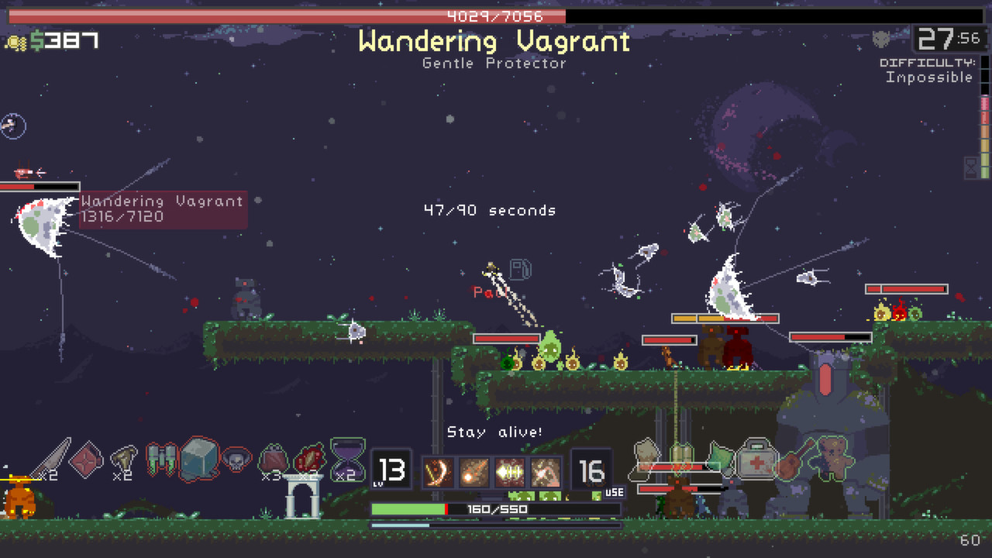

Figure 2 - Risk of Rain Gameplay

Both Slay The Spire and Risk of Rain employ perma-death mechanics, adding a challenging dimension to each playthrough as players face permanent consequences for failure. Additionally, both games feature a gradual progression system where players unlock items and upgrades over time. This dual approach, combining risk with persistent rewards, fosters replayability and strategic depth. Players must adapt and refine their strategies in the face of perma-death consequences while enjoying the satisfaction of unlocking new elements, ensuring each playthrough remains engaging and distinctive. These two mechanisms are core features also present in HullBreaker.

### 2.2.3. Unique Selling Points

HullBreaker unique selling points are its unique combat system and its use of subversions to the roguelike genre. Within the roguelike genre, especially in turn-based roguelike games, the player is often set down a linear path for there progression through the game. HullBreaker aims to give the player more freedom in their exploration of the game world and offers the player a semi-open world game map to navigate.

HullBreakers combat system is also one that is never often seen in roguelike games and is limited mostly to use in turn-based RPG games. HullBreaker offers player a fresh combat experience with unique mechanics and systems to engage with.

## 2.3. Technical Investigation

### 2.3.1. Target hardware for Deployment

HullBreaker will be available on PCs running windows 8 or higher:

Operating System: Windows 8+

Processor: Intel Core i5+

Memory: 2GB RAM

Graphics: Nvidia GTX 460 or better

Storage: Unknown

### 2.3.2. Development hardware and software

HullBreaker will be developed on a PC with the following specifications:

Operating System: Windows 11

Processor: AMD Ryzen 5 5600G

Memory: 16GB RAM

Graphics: Nvidia GeForce RTX 3060

### 2.3.3. Game Engine

HullBreaker is made using the Unity game engine. Unity, developed by Unity Technologies, is a versatile game engine for creating 2D and 3D games across platforms. Known for its user-friendly interface and support for C# scripting, Unity is popular among beginner and advanced developers. Unity was chosen as the game engine for HullBreaker as it has many features and various plugins that make development more streamlined and easier, especially for a one-person development team.

The chosen version of Unity used for development is the 2021.3.26f1 version.

### 2.3.4. Scripting Language

HullBreakers scripting language of choice is C#. C# (C sharp) is a modern, object-oriented programming language developed by Microsoft, renowned for its simplicity and efficiency in building applications across platforms. As an object-oriented language, C# promotes modular code organization, enhancing developers' ability to manage and scale projects effectively. C# was chosen as it is the language that is most understood by the developer, it is directly supported by Unity, the games engine and it is relatively easy to write and understand.

# 3. Project Management

## 3.1. Project Methodology

The chosen methodology that HullBreaker uses for its development is Scrum.

In the realm of game development, where iterative progress and adaptability are crucial, Scrum has gained widespread adoption for its effectiveness in managing complex projects. The Scrum framework is applied to game development by organizing the process into sprints, typically lasting two to four weeks. During each sprint, the development team collaborates to deliver a potentially shippable increment of the game.

Adopting Scrum in game development offers several benefits. It allows developers to respond to changing requirements and market dynamics efficiently. The iterative nature of Scrum aligns well with the creative and iterative nature of game design, enabling developers to incorporate player feedback and adjust throughout the development cycle. This agile approach contributes to more predictable development timelines and higher-quality games as issues are identified and addressed early in the process.

Scrum was chosen as it allows for easier breakdowns of complex tasks into smaller manageable portions. Having smaller lists of tasks that are to be tackled at the start of each sprint makes the development of HullBreaker much easier. Here is a breakdown of the components of scrum that are and are not used in this project:

|  |  |  |
| --- | --- | --- |
| Scrum Component | Used? | Reason |
| Assigned Roles | No | This is a solo project there is no need for assigned roles |
| Daily Stand-ups | No | This is a solo project there is no need for daily stand-ups |
| Next Sprint Plannings | Yes | Each sprints work is planned at the end of the previous sprints |
| Sprint Reviews | Yes | There is a review at the end of each sprint |
| Sprints | Yes | Every two weeks |
| Product Backlog | Yes | Used to assign tasks at the beginning of each sprint |
| Sprint Backlog | Yes | Used to carry over work from previous sprints |
| Scrum Board | Yes | Trello used as a scrum board to manage sprints |

Table 1 - Scrum Components

## 3.2. Detailed Schedule

|  |  |  |  |  |  |
| --- | --- | --- | --- | --- | --- |
| Sprint # | End Date | Duration (Weeks) | Deliverables | Progress | DevLogs |
| 1 | 5/10/2023 | 2 | * GDD 4.1 * Prototype started. * GDD 3.7 * Prototype Assets | Complete | [Devlog](https://www.youtube.com/watch?v=9d9cGrX6shk&list=PLN2RTZi90m-QxoqgEXHS_zz7dc4ub7ubA&index=1) |
| 2 | 19/10/2023 | 3 | * Map Generation Prototype * Grid System Prototype * GDD Section 4 progress | Complete | [Devlog](https://www.youtube.com/watch?v=GQZyDtT5vS8&list=PLN2RTZi90m-QxoqgEXHS_zz7dc4ub7ubA&index=2) |
| 3 | 9/11/2023 | 2 | * Scriptable Objects for Cards and Ships * GDD Section 4 | Complete | [Devlog](https://www.youtube.com/watch?v=e74DjNpcYDw&list=PLN2RTZi90m-QxoqgEXHS_zz7dc4ub7ubA&index=3) |
| 4 | 23/11/2023 | 2 | * GDD Section 5 * Further Development on Scriptable Objects | Complete | [Devlog](https://www.youtube.com/watch?v=EIM7ckBKA_Q&list=PLN2RTZi90m-QxoqgEXHS_zz7dc4ub7ubA&index=4) |
| 5 | 7/12/2023 | 2 | * Clear Vision of game developed. * Progress on GDD | Complete | [Devlog](https://youtu.be/n1FBTLW8erI?list=PLN2RTZi90m-QxoqgEXHS_zz7dc4ub7ubA) |
| 6 | 21/21/2023 | 2 | * Brand New Combat system prototyped. * GDD 6.1 – 6.1 | Complete | [Devlog](https://youtu.be/8ih7vkxYPQk?list=PLN2RTZi90m-QxoqgEXHS_zz7dc4ub7ubA) |

Table 2 – Devlog Schedule

## 3.3. Schedule Management

Trello is used to manage a scrum board and is updated during each sprint to reflect the work being done and the work completed.

This Trello board can be via the following link here: <https://trello.com/b/ipX7ZOWC/fyp-anthony-okeeffe-hullbreaker>

## 3.4. Version Control

HullBreakers version control is managed using GitHub.

GitHub allows for easy linking with Unity projects and also has many useful features such as branching, which can be used for testing various version of the game and also functions to provide a backup for the games files in case it would become corrupted or somehow deleted.

The link to the development repo can be found here:

<https://github.com/GuyGoose/FYP_Material>

## 3.5. Risk Analysis

|  |  |  |  |
| --- | --- | --- | --- |
| Risk | Risk Likelihood | Risk Impact | How to Avoid? |
| Project scope to large | High | High | Prioritizing core mechanics and cutting back on any unnecessary features |
| Asset creation to time consuming | Medium-High | Low | Will hopefully be fully handmade but if time becomes an issue can be outsourced |
| Certain features take longer than others | Medium | Medium | Planning out the best implementation of these features so they can easily integrate with little modification down the line |
| Sickness/Absence | Low | Medium | Keeping ahead on work so I can allow some breaks if needed |
| File corruption | Low | HIGH | Frequent commits to GitHub and saving local backups at crucial points |

Table 3 – Risk Analysis

## 3.6. Test Plan

HullBreakers test plan is carried out in phases. With each main version release of the game a test group will be gathered to undergo a test of mechanics and features introduced and highlighted in that current release. The test groups for these testing phases are gathered through a variety of sources, those being:

* Volunteer testers from the university campus.
* Friends and family of developer.
* Volunteer online testers.

The tests on campus will be performed in-person, with the testers playing the version demo and the developer taking notes and feedback. During this time testers are not asked questions about their experience with the game and any questions will be withheld until the end of the testing phase. The tests using friends, family and online testers are used as a more casual and overtime testing source, such as for testing small feature implementation on the fly and bug fixing.

The metrics and data that will be taken from these testing phases will be:

* How quickly the tester understands the mechanisms of the game.
* Portions of the game they struggle in.
* Portions of the game they progress quickly through.
* Observing how the tester is playing the game. (Are they focused, confused, relaxed etc.)
* How long they take in each game screen (Menus, Combat, Navigation, etc.)
* If they are expressing enjoyment or frustration with the game’s difficulty.

Alongside this gathered data, testers will also be given a feedback sheet to fill in upon completion of testing with the following questions:

* How much did you enjoy this version of HullBreaker? (Scale of 1-10)
* Why? What did you enjoy and what did you dislike?
* What do think would be a welcome addition to HullBreaker to make your gameplay experience better?
* How did each of these aspects of the game feel? (Scale of 1-10 + Comment)
  + Combat?
  + Navigating menus?
  + Navigating the map?

These questions can vary depending on if a certain key feature or mechanic of the game is being tested during that testing phase.

# 4. Project Design

## 4.1. Gameplay

### 4.1.1. Game Progression

In HullBreaker the player progresses by exploring the current system they are in, defeating the system boss to progress to the next. Each system can take anywhere from 10 to 20 minutes to locate the boss without taking exploration time into the equation. Due to the open world navigation system of the game the player could choose to fully explore a system before progressing to the next to maximise their strength, however doing this will cause the games dynamic difficulty to ramp up enemy strength to account for the players increased power. As the defeat more enemies in a system an invisible stat called “Notoriety” will increase, enemy stats such as damage, health and even number of enemies will increase proportionally with this score. Even if the player defeats a system boss with a low notoriety score it will be set to a flat amount upon entering the next system.

### 4.1.2. Mission/Challenge Structure

The mission of the characters in HullBreaker varies between them but each character’s overall goal is to defeat the 3 system bosses.

These 3 bosses are chosen at random upon beginning a run and each system has a pool of 3 bosses that can be occupying them, making for a total of 9 unique boss encounters.

### 4.1.3. Objectives

The objective of HullBreaker is to defeat all three area bosses and take revenge on the HullBreakers Inc. executives.

### 4.1.4. Play Flow

The flow of the game and how fast it is played is largely dictated by the player and there play style. The player can choose to take as little encounters as possible and speed through the games content or explore each encounter and event for a longer game play experience. The slower more methodical playstyle may result in players gaining more power than initially intended but HullBreakers dynamic difficulty will counter act this issue.

## 4.2. Mechanics

### 4.2.1. Navigation

HullBreakers navigation system is made to be open and expansive. The player will traverse the game world via a “Universe Map”, this map consists of three concentric rings containing encounter various planets or locations. These rings are our systems. These systems are named as such:

* The Inner System / “The Heap”
  + The Players starting point.
  + Contains the easiest encounters and events.
  + Has a central planet named “Hull-Haven”, a shop whose contents will update as the player progresses. (Each time a boss is defeated)
  + Contains the first boss.
* The Middle System / “The Planes”
  + The System accessed after defeating the first boss.
  + More difficult encounters and more diverse events.
  + More likely to contain planets with shops or ship bays.
  + Contains the second boss.
* The Outer System / “The Beyond”
  + The System accessed after defeating the second boss.
  + Contains the most difficult encounters and events can prove more hazardous.
  + Less likely to contain planets with shops or ship bays but will contain higher value upgrades and ships.
  + Contains the third and final boss.

These systems all contain several “Destination points”. These points make up the spaces which the players fleet traverse. They can be empty and simply serve as a connection for more points or they could contain an encounter, event, shop, ship bay, etc. The player navigates these points via clicking a point adjacent to the one they reside in and choosing to travel there. This form of world map and navigation takes heavy inspiration from Stellaris (Paradox, 2016), a similarly sci-fi space themed game.

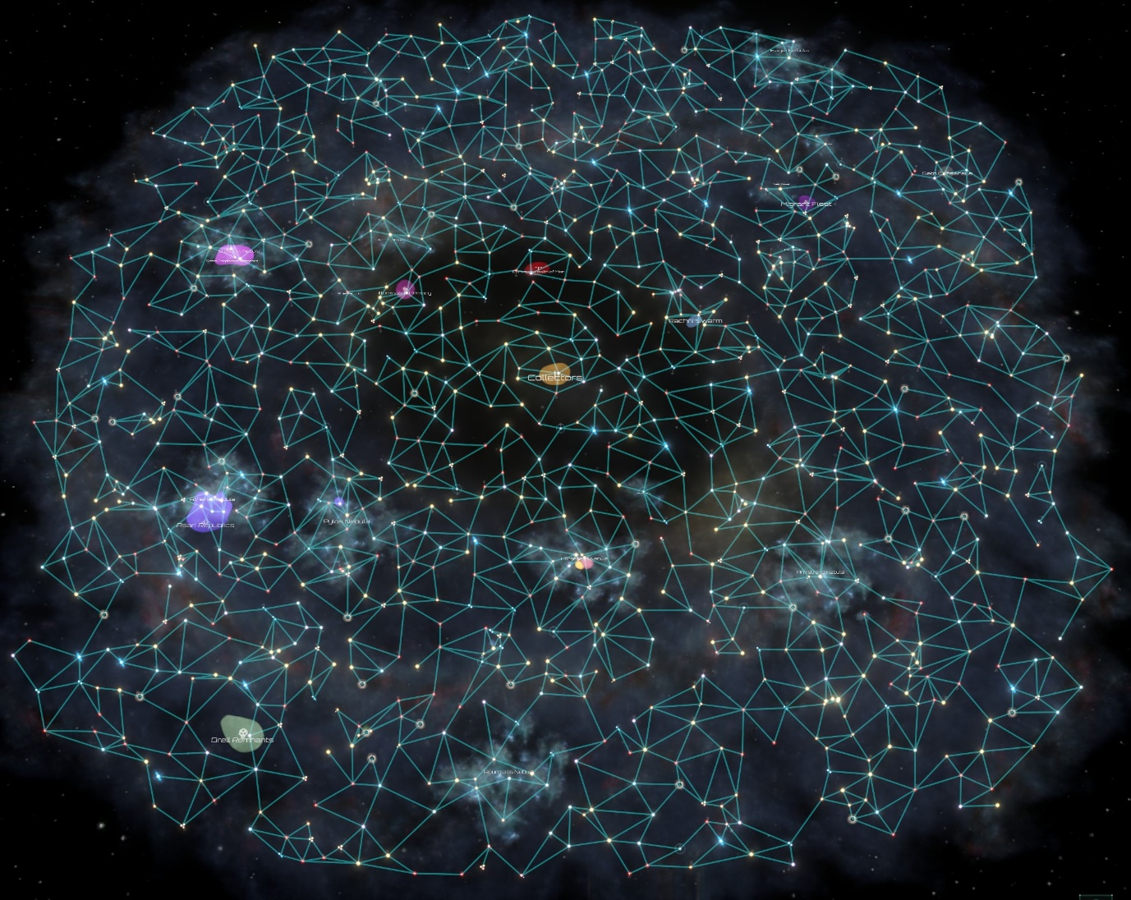

Figure 3 - The default map type in stellaris

### 4.2.2. Encounters and Events

When traversing the system map the player will find various encounter and event areas.

Encounters are when the player locates another fleet of ships on a destination point. If an adjacent point contains a hostile encounter, it will be displayed with a RED exclamation mark. If the encounter can be avoided via alternative means (e.g. Paying off the enemies, dialogue options, etc.) Then it will be displayed with a YELLOW exclamation mark. If the encounter point is friendly, it will be displayed with a GREEN exclamation mark. What determines if these encounter points are hostile or not is the players relations with various factions in the game.

Events can occur somewhat rarely on destination points. These are indicated on adjacent destination points with a question mark. Events vary wildly can contain any combination of free upgrades, an encounter, dialogue that can yield upgrades or encounters or both, etc. Examples of some events include:

* Asteroids – The player encounters an asteroid field:
  + Avoid? – Skip event, nothing gained.
  + Explore? –
    - 50% chance: Take X amount of damage.
    - 30% chance: Find an upgrade.
    - 15% chance: Nothing happens.
    - 5% chance: Unique encounter. (Elite Enemy)
* Enforcer Checkpoint – The player encounters an enforcer checkpoint.
  + If positive with enforcer faction – Free passage.
  + If neutral with enforcer faction – Pay a fee.
    - Cannot pay fee? – Encounter.
  + If negative with enforcer faction – Encounter.
* And many more…

### 4.2.3. Factions

In the world which HullBreaker takes place there are many factions of people and creatures. Some destination points are populated with people form these factions and how they interact with the player will be dependent on their relations with their faction. If a point is occupied by a faction an icon showing their insignia will be visible on the map. Each starting character has their own amount of reputation with these factions, but the player can also gain and lose favour with any of them depending on their actions within a run.

The factions present in the game are as follows:

* **Enforcers** – The law enforcement in the game world.
  + Hate: Outlaws, Cultists
  + Neutral: Ex-Employees
  + Like: Enforcers, HullBreaker Group
* **Outlaws** – Scavengers who take what they want.
  + Hate: Enforcers, Cultists
  + Neutral: Outlaws, Ex-Employees, HullBreaker Group
  + Like: None
* **Cultists** – Dogmatic worshippers of a god of scrap.
  + Hate: Outlaws, Enforcers, HullBreaker Group
  + Neutral: Ex-Employees
  + Like: Cultists
* **Ex-Employees** – People affected by the closing of “HullBreaker Inc.”
  + Hate: HullBreaker Group
  + Neutral: Everyone
  + Like: None
* **HullBreaker Group** – Bodyguards and Bosses of “HullBreaker Inc.”
  + Hate: Ex-Employees, Cultists, Outlaws
  + Neutral: None
  + Like: HullBreaker Group, Enforcers

### 4.2.4. Turn-Based Combat

The combat in HullBreaker is a combination of traditional turn-based RPG combat and aspects from more modern deck-building roguelikes.

Combat starts with the player being presented a screen showing the players ships, all their actions and their fleets health and energy. The player can also see the enemy ships that they encountered, the health of each of these ships and a preview on the actions that the enemies intend to take on their turn. Here is a breakdown of what happens during the players turn:

1. The player turn starts.
2. The enemies display what actions they intend to take on their turn.
3. The player gains the max amount of energy they can have currently (4-12)
4. The player can spend this energy on actions displayed on the action menus for each ship.
5. These selected actions are added to a player action queue.
6. The players turn ends.

Once the player finishes there turn the enemies then take theirs. Here is a breakdown of the enemies turn:

1. The enemies turn starts.
2. The actions that the player chose during their turn are executed.
3. The enemies, one by one will execute the actions that they forecast during the players turn.
4. Any debuffs on enemies take effect (eg. poison damage)
5. The enemies turn ends.

After the enemies turn finishes it is then passed back to the players turn in which the cycle repeats until all enemies have been defeated or the players health is depleted.

If all enemies are defeated during a combat the player is presented with a screen offering them a reward (eg. Upgrades, money, ship parts, etc.) The player takes their reward and is then brought out to the navigation map to further progress. If the player is defeated during combat, they are brought to a game over screen showing their statistics and their run ends. They are shown anything they may have unlocked during their run and are brought to the main menu.

Below is an example of how the players stats are constructed in-game:

**Player Stats**

* **Health**: 50 + 50 per ship
* **Total actions**: 4 + 4 per ship (Max – 16)
* **Energy**: 3 + 3 per ship (Max – 12)

## 4.3. Screen Flow

When HullBreaker is launched it will play a short opening cinematic followed by the main menu screen.

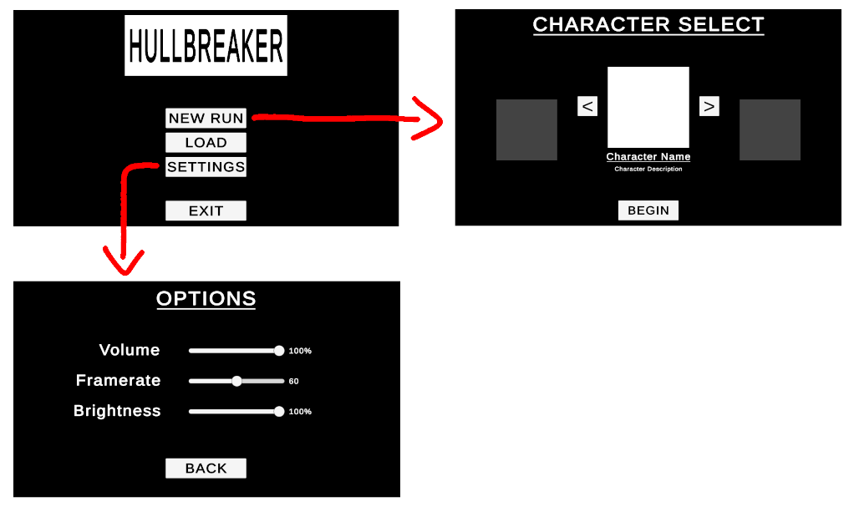

Figure 4 - Main Menu Flow

When the game is paused the pause screen will be shown.

Figure 5 - Pause Menu Flow

### 4.3.1. Description of Game Screens

#### Main Menu

The displayed upon starting the game. The “New Run” button will take the player to the character selection screen. The “Load” button will load any previous save the player has. Finally, the “Quit” button will exit the game.

Figure 6 - The Main Menu

#### Settings Menu

The player is offered three settings to adjust. Volume can be adjusted from 0-100%. Brightness will adjust a brightness filter on the game with a range of 0-100%. Lastly the framerate can also be adjusted, the slider is fixed at three positions so the options for framerate are 30 fps, 60fps and unlimited.

Figure 7 - The Settings Menu

#### Character Select Menu

The character select screen shows a portrait of the currently selected character, the characters name and description. To the sides or the portrait are arrows which allow the player to cycle through the other available characters in the game. With a character selected the player can press the “Begin” button to start a new run as the selected character.

Figure 8 - The Character Select Menu

#### Pause Menu

When escape is pressed during a run the pause menu is brought up. From this menu the player can navigate to the settings menu using the “Settings” button. The player can also press the “Save” button to save at there current point in the game. At the bottom there is a “Save & Exit” button which when pressed will save and exit from the game. Lastly “Continue” can be pressed in order to un-pause the game and close the pause menu.

Figure 9 - The Pause Menu

## 4.4. Game Options

From the options menu the player can adjust some settings in the game. These settings are:

* Volume: Range 0-100%
* Framerate: Range 30/60/Unlimited
* Brightness: Range 0-100%

## 4.5. Replaying and Saving

The player can save the game at any point during a run by bringing up the pause menu and pressing “Save” or “Save & Exit”. This will allow the player to, upon going to the main menu with a valid saved game, press the “Load” button and be brought back to the position on the map which they saved at.

4.6. Story and Narrative  
The story and events of HullBreaker are not set in stone and can vary playthrough to playthrough, this is the case for many roguelike games. For this reason the background and story for each playable character is very simplified and many of them share story aspects with each other.

### 4.6.1 Backstory

In a galaxy far away in the year 80XX there is a system named “Alpha 13”. This system was owned and operated by the company known as “HullBreakers Inc.”, a company specialized in the dismantling and repurposing of abandoned ships, cities, and planets. A salvage company. *The* salvage company. In day and age where all intelligent life has spread far and wide across the endless universe they serve as a dim beacon of commerce and industry. They have become so widespread and rich by distributing unused resources across the galaxy that many systems now require their presence to simply exist. “Alpha 13” was one of these systems. Due to a widespread lack of education, the employees of HullBreakers Inc. are not some sort of “trained salvage professionals” but people skilled in destruction. Demolitionists, Arsonists, Ex-Cops, Mercenaries, if they can destroy and break apart ships and buildings the company employed them. The system seemed flawless, give the psychopaths and criminals of the system something to destroy and the company gets scrap in return.

Until one faithful day in which a system wide announcement went out to all civilians, and workers of the HullBreakers Inc.

“COMMENCING IMMEDIATELY ALL OPERATIONS AND TRADE WILL CEASE INVOLVING HULLBREAKERS INC. WE ARE SORRY FOR ANY INCONVENIENCE CAUSED”

At the moment the message was transmitted a system wide EMP was unleased from the other edges Alpha 13, causing all company machinery and systems stop functioning.

This sent the entirety of Alpha 13 into a panic and a system wide riot broke out. The bosses of the company where not to be heard of and every person and creature across the system broke up into factions as nonstop war for resources broke out.

Among these factions a certain few people standout. Ex-Employees of HullBreakers Inc. Not only where they left in the dark by their superiors, but they were thrown away like everyone else at the end. They had enough. They weren’t going to be treated like tools and thrown away. Each one of them were going to give their bosses a, *very painful,* piece of their mind.

And so, they set out. To seek revenge on the system bosses who abandoned them.

### 4.6.2 Plot Elements

The plot of HullBreaker is structured using Freytag’s Pyramid. This technique is type of storytelling structure written by Gustav Freytag and is a technique which expands upon Aristotle’s classic unified plot structure, a story with a beginning, middle and end. Freytag’s Pyramid expanded upon the unified plot structure by further defining the three main points and by introducing four extra story beats, the culmination of these being:

* Exposition – Background information.
* Inciting Incident – The first conflict.
* Rising Action – Three~ events that add suspense or tension.
* Climax – The height of suspense / the turning point.
* Falling Action – The events that unravel the conflict.
* Resolution – The resolution.

In adherence to this structure, HullBreakers story is structured as follows:

##### **Exposition**

A short cutscene that introduces the world and HullBreakers Inc. Explained through images and minimal text.

##### **Inciting Incident**

The company shutting down operations and the ex-employees setting out for revenge.

##### **Rising Action**

Presented through the three boss fights present in the game, each adding a little exposition to why the company closed.

##### **Climax**

Takes place during the final boss fight where all is unveiled in relation to why the company closed.

##### **Falling Action**

With the bosses of the company dead the system wide war ends as everyone joins in celebration.

##### **Resolution**

The player character takes control of the company and restores all its facilities under new management.

### 4.6.3 Game Progression

HullBreakers game progression works area by area. Each area has a beginning and end but due to the loose nature in how the game can be played the middle is less rigid and is not very narrative heavy. The middle of each area is mostly contained for the player to progress through the game, encountering enemy ships, interacting with events and so on. The start of each area will be a short introduction for the player in the form of a cutscene. The end will be the boss fight and the story elements gained from it.

### 4.6.4 Cut Scenes

Cutscenes in HullBreaker will consist of mostly images and leave test to minimum, the only time it is used is when the name of something will be displayed. This is to let a mysterious feeling envelope the game and to only give as much is needed. The principle of HullBreakers cutscenes is very much take from the phrase “Show, don’t tell.”

An example of how a cutscene is handled:

#### **Cut scene #1 – The Intro**

##### Actors

The player characters, The bosses of HullBreakers Inc., The leaders of each faction

##### Description

The cutscene will introduce the game world to the player. This includes the companies rise to power, the ensuing war of factions when they shutdown and the player characters preparing to embark for revenge.

##### Storyboard

1. Images of barren planets with no activity fades onto screen, the words “Alpha 13” appear.
2. The barren planets are then suddenly replaced with images of them in there current day industrialized state. Below the “Alpha 13” text the words “Owned and operated by HullBreakers Inc.” now appear.
3. Images of ships flying planet to planet. Trade, commerce, and the system functioning. Silhouettes of the player characters are seen doing their jobs for the company.
4. An image of the company logo appears. It shines brightly for moment until its light begins to flicker.
5. A far zoom out occurs as a wave of energy passes over the whole system, causing every planet to go dark. The company’s announcement message is seen.
6. Ensuing are images of interplanetary conflict. Flashes of each faction and their leaders locked in conflict with one another.
7. The player character silhouette appears again, lined up and eyes red with anger.
8. One steps forward, a man named “Joe Aveg”, the first playable character.
9. He holds up a piece of paper with the company bosses faces on it, he crushes the list in his hand.
10. He and the other player character walk towards there ships as the games title fades onto screen.

## 4.7. Game World

### 4.7.1. General Look and Feel of The World

HullBreakers world is set in a far-off future where humans, alongside other races, have conquered the stars but are beginning to become low on resources. The buildings on every planet are either cobbled together housing and markets made of scrap metal and machinery or tall, towering industrial complexes. All planets have their function, either they are resource world, mass homes for faction members or the undecided (Those without a faction) or giant spiralling market for scrap metal ships, mercenaries and weapons.

### 4.7.2. Areas

**The Inner System / “The Heap” –**

The inner most part of the system. Characterised by its tower buildings on almost every planet and its large central world by the name of “Hull-Haven”. Has become the main hub of commerce in the new “post company” world but still has its fair share of conflict.

**The Middle System / “The Planes” –**

The second ring of the system. Sometimes referred to as “The Planes” or “The Wild Centre” by its inhabitant. It is middle ground for most conflict in the system. Trading is sparser and those who wander the area are in conflict or are looking to pillage and salvage anything they can find. The planets are less developed than those in “The Heap” and majority serve as homes for the displaced in the system but are always getting caught in the crossfire of some conflict.

**The Outer System / “The Beyond” –**

The outer ring of the system. Contains worlds that are unexplored or inhabitable. Referred to by most as “The Beyond” as no one knows exactly what’s out there. Populated the strongest of enemies and people in power who have gone into hiding. Barren and dead planets that have become either overgrown and reclaimed by nature or have been polluted beyond saving.

## 4.8. Characters

Due to the ever expanding of characters not all characters seen HullBreaker will be shown. Below are some of the first characters that are shown in the game:

### 4.8.1 Character #1 – Joe Aveg

**Role – The First Playable Character**

**Backstory**

Joe was just another average worker for HullBreakers Inc. He used to be a scrap yard worker and even once had a job in demolition. To the company he was the perfect asset. Hard worker, good experience and loyal to money. But there was just something strange about Joe. He was quiet, emotionless, and never seemed to get angry or even happy for that matter. Some people said he was a psychopath, that he had no emotion. Joe didn’t care. As long as money kept flowing, he’d keep working.

But when the money stopped flowing, Joe felt something. The slightest twinge of emotion for the first time. ***Betrayal***. And so, he set out to rid himself of this feeling, this uncomfortable new sensation. When the people that betrayed him ain’t breathing no more, then Joe can live soundly again. Quiet and unfeeling. Just your average Joe.

**Personality**

Quiet, Unemotional, Cold and calculating but loyal to those who benefit him.

**Appearance**

A bland and blank expression. Soulless eyes and a cold demeanour.

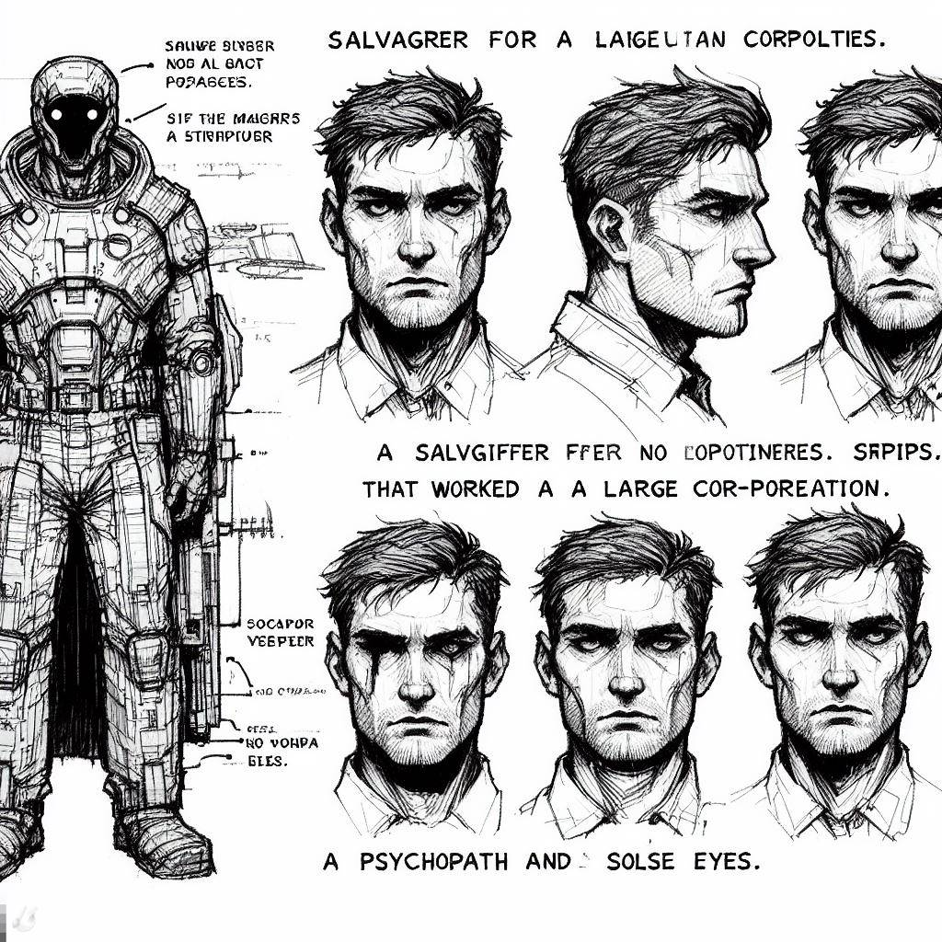**Physical Characteristics**

Figure 10 - Joe's Concept, Dall E 3 (2023)

Somewhat muscular from past work experience. Some scarring across parts of the body and face.

**Animations**

Shown mostly through character portraits. Will have subtle animations for:

* Idling
* Talking
* Being Hurt
* Heavily Damaged
* Winning a combat
* Death

**Special Abilities**

He is the starting character, so his abilities are not complex but are as follows:

* Ability Name - In A Silent Way
  + Joe is considered neutral to all factions at the start of the game.
* Ability Name – Salvage Experience
  + Joe gains more rewards and money at the end of a combat.

**Relevance to Game Story**

Joe is the first playable character the player gets to use and is one of the main characters of HullBreaker.

### 4.8.2 Character #2 – Johny Raats

**Role – One of bosses of HullBreakers Inc.**

**Backstory**

Johny is one of the bosses of HullBreakers Inc. and runs the black-market trade that the company engages in. His race have a short lifespan of only a few years so he is part of the 50th generation of his family that run the company. His family has deep roots in the back-alley trade that occurred in Alpha 13 before the company arrived, so his family joined them as a way to make their illegal business easier. He is getting old for his race and for this reason he is becoming more daring and dangerous as he approaches the end of his life. He still resides in The Heap even after most of the company bosses left and went into hiding.

**Personality**

Sly and shady, untrustworthy, and wild when backed into a corner.

**Appearance**

Rat faced with dark eyes. Greying with age and always wearing a suit.

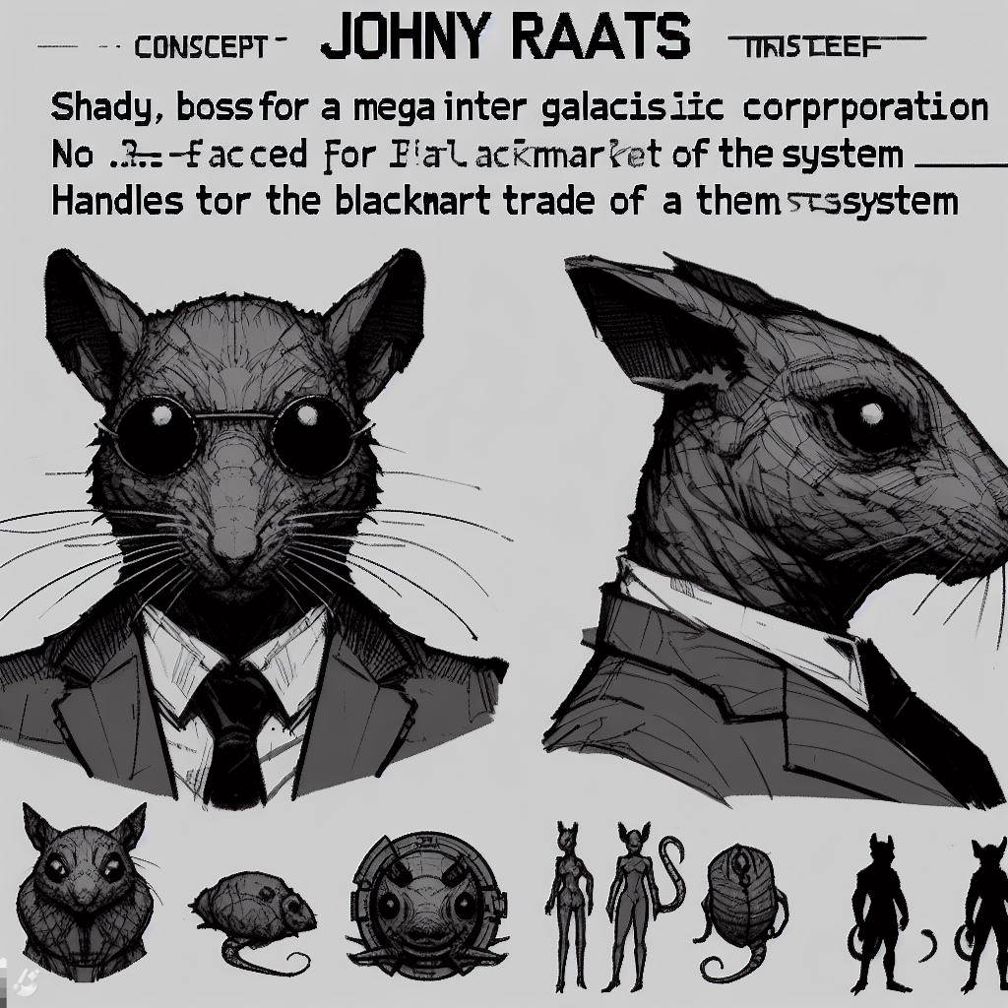

Figure 11 - Johny Raats Concept, Dall E 3 (2023)

**Physical Characteristics**

Slender build and tall. A commanding but sickening presence.

**Animations**

Portrait animations include:

* Idling
* Talking
* Being Hurt
* Heavily Damaged
* Death
* Enraged Animations (When ability activates)

**Special Abilities**

Johny is one of the first bosses the player can encounter and has one ability that serves as his key mechanic.

* Ability Name – Backed in A Corner
  + When the ships that surround Johnys are destroyed he will become enraged and deal more damage but will also take increased damage.

**Relevance to Game Story**

Johny is one of the bosses of HullBreaker Inc. and serves as one of the games antagonists. He provides exposition as to why the company closed upon his defeat.

## 4.9. Levels

### 4.9.1. Overview

HullBreaker will feature three levels, The Heap, The Planes and The Beyond

### 4.9.2. Beat Chart

Level #1 – The Heap / The Inner System

|  |  |  |  |
| --- | --- | --- | --- |
|  | **Level 1: The Heap** | **Level 2: The Planes** | **Level 3: The Beyond** |
| **Location** | The Inner System | The Middle System | The Outer System |
| **Story beat** | The player begins their journey | More details on the company are revealed | The climax and final confrontation with the company |
| **Progression** | Players gains there first ship and upgrades | Another ship is gained and more upgrades | The final ships is gained and higher quality upgrades |
| **Est. play time** | 20 minutes | 20 minutes | 20 minutes |
| **Colour map** | Black and white, grey tones used as highlights | Black and white, lime/green tones used as highlights | Black and white, red/purple tones used as highlights |
| **Encounters** | Outlaws, Enforcers, HullBreaker Group | Outlaws, Enforcers, HullBreaker Group, Cultists | HullBreaker Group, Cultists |
| **Mechanics** | Contains more shops than other zones, enemies yield more money | Tougher enemies, less shops and money but upgrades are more frequent | The hardest of all enemies and the best upgrades but both are less frequent |
| **Events** | Non-lethal, faction relation effecting | Become more dangerous but higher quality rewards | Can be lethal and lead to tough encounters |
| **Economy** | The richest of the zones, lots of markets | Less money than The Heap and fewer shops | Virtually none unless you can trade with cultists |
| **Music Track** | The Cities of Scrap | Wild Green Yonder | Silence |

Table 5 – Beat Chart

### 4.9.3 Level #1 – The Heap

#### 4.9.3.1. Synopsis

This where the player begins their journey and where they will acquire there first few upgrades and there first ally ship.

#### 4.9.3.2. Introductory Material

The player is shown a short cutscene of the events following the intro cutscene. This cutscenes material can vary depending on the players selected character in order to show a short insight into that character backstory. If it is the players first playthrough they will also be prompted with short tutorial messages to explain key mechanics and features.

#### 4.9.3.3. Objectives

The objective of the first level is to offer the player an introduction to the game and its various mechanics. They will learn the core mechanics of the game, them being the combat, shop and navigation. Once the player is comfortable with the game, they can choose to seek out the area boss and progress to the next level.

#### 4.9.3.4. Physical Description

A densely packed system of industrial planets and space stations. The planets themselves are industrious complexes of housing and markets. Between the planets some conflicts and fights can be seen.

#### 4.9.3.5. Map

The centre of the system. Lots of destination points to travel to and a central shop planet. The three big points of interest are points where the player can cross into The Planes, although this will mean confronting one of the area bosses.

Figure 12 - Example of the inner system

#### 4.9.3.6. Critical Path

There is no defined critical path. The player may choose to b-line it to boss or to take their time and explore the system.

#### 4.9.3.7. Encounters

The player will encounter a couple different enemies here, mostly bandit Outlaws, violent Enforcers, and corrupt merchants. The area boss is also required to be defeated to progress.

### 4.9.4 Level #2 – The Planes

#### 4.9.4.1. Synopsis

Where player continues their journey after exiting The Heap. Player is introduced to new tougher enemies and events.

#### 4.9.4.2. Objectives

The objective of the second level is to test the player. The difficulty of enemies and events is ramped up and shops become less frequent. The player must learn to use there acquired upgrades and actions to progress through the second level.

#### 4.9.4.3. Physical Description

A Less densely packed region of the system but harbours much more conflict and danger then the other regions. Some planets are old and abandoned but are not yet uninhabitable and thus may harbour resources useful to the player. The towering buildings on planets become shorter and the lime green hues of the universe shine through a little more.

#### 4.9.4.4. Map

The middle ring of the system. More destination points then The Heap but spread over a wider area. Has three similar large points for traversing into The Beyond. The familiar three large boss points are also present but with the danger of the area, the player may feel more comfortable just heading for the nearest point.

Figure 13 - Example of The Middle System

#### 4.9.4.5. Encounters

Encounters become more difficult and new factions begin to appear. The Enforcers and Outlaws have more battle-ready ships with stronger attacks and abilities and the Cultists now sometimes appear with their strange, divine weaponry.

### 4.9.5 Level #3 – The Beyond

#### 4.9.5.1. Synopsis

Where the player will be met with there toughest encounters and most deadly events. Where the journey ends.

#### 4.9.5.2. Objectives

The player’s objectives are to gather any remaining upgrades they can and prepare to face the final boss of the game. Encounters are the hardest they can be, events are highly dangerous, and shops are near non-existent. The final objective is to simply survive.

#### 4.9.5.3. Physical Description

The edges of the system. Planets are untouched and barren and those with infrastructure are home to hostile outlanders or churches of the scrap Cultists. The area takes on a strange and mysterious vibe and adopts using harsher red and violet tones to highlight important areas.

#### 4.9.5.4. Map

The outside ring. Destination points are spread far from each other and each harbours some form of threat.

Figure 14 - Example of The Outer System

#### 4.9.5.5. Encounters

To far out for the Enforcers to enforce and to dangerous for the Outlaws to dare and go. Populated entirely by Cultists, lackeys of the company and large space creatures. Is also home to the final and penultimate boss of the game.

## 4.10. Interface

### 4.10.1. Visual System

#### 4.10.1.1. Combat HUD

The HUD in HullBreaker will display the players current energy, health, shield, currently available actions and the “End Turn” button. The menu in the top left is of the players currently available actions and the portrait of the character with those actions. Depending on the number of ships the player has there will more of these action menus with a max of four.

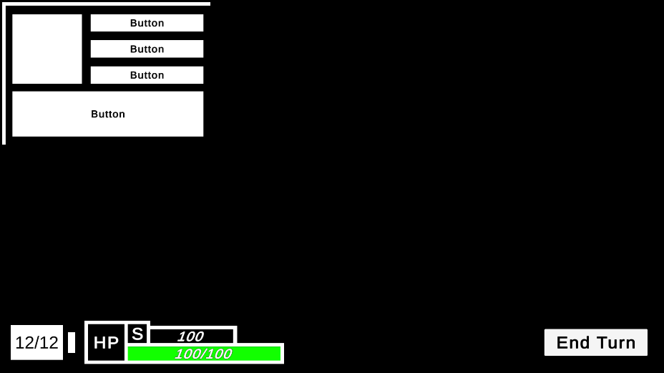

Figure 15 - Combat HUD

#### 4.10.1.2. Menus

The pause menu (Seen in figure 5) will allow the player to access the games options menu for adjusting their settings, exit the game and save or to continue from where they paused.

The options menu provides the player with the choice to adjust their volume, brightness, and framerate settings. The options menu can be navigated out of by pressing the “Back” button.

#### 4.10.1.3. Camera

HullBreakers camera is mostly fixed although it does utilize certain features of Unitys cinemachine camera in certain situations. When navigating the system, the camera will track and smoothly follow behind the players ship. There is also a camera shake effect that occurs upon the player taking large amounts of damage or by dealing a lot of damage.

### 4.10.2. Control System

HullBreaker is made with the idea of being played using a keyboard and mouse.

Keyboard and Mouse

Figure 16 - Keyboard and Mouse Diagram

|  |  |
| --- | --- |
| W | Zoom in |
| S | Zoom out |
| Left Mouse Click | Interact |
| Right Mouse Click | Undo Interaction |
| Esc | Pause |
| Tab | Check ship status |
| E (or left mouse) | Progress dialogue |

Table 6 - Controls

### 4.10.3. Audio

#### 4.10.3.1. Music

The music of HullBreaker is made both by hand and by using free third-party available tracks and soundbites.

There are music tracks for each area, combat, boss fights, menu and also a general background track.

#### 4.10.3.2. Non-Music

The various sound effects in HullBreaker are but are not limited to:

* Navigating
* Taking Damage
* Dealing Damage (several for different attacks)
* Restoring Health
* Gain Shield
* Gaining Buffs and Debuffs
* Dying
* Enemies Taking Damage
* Enemies Dealing Damage (several for different attacks)
* Abilities Activations
* Menu UI Sound Effects
* Etc.

### 4.10.4. Help System

The help system in the HullBreaker is aimed at providing new players a welcoming and well explained first few playthroughs. Upon playing the game for the first time the players will receive various tips and tutorials via a UI popup in order to inform the player about various mechanics and systems.

There is option to disable and enable these popups at any time in case the player no longer needs them or if they want a refresher on the mechanics present in the game.

## 4.11. Artificial Intelligence

The artificial intelligence in HullBreaker is minimal but is used in some key portions of the game.

Enemies normally cycle down a predetermined list of actions during there turn but if the player is performing very well and an increase in difficulty occurs then enemies will be more likely to use higher damaging attacks and perform stronger actions.

Normal Enemies

* Cycle down a list of actions and perform those actions on their turn.
  + There are slight variations in these actions and some enemies of the same type may have different actions.
* If the player is performing well then, the enemy gains access to actions of a higher quality and may choose from them.

Bosses

* Cycle down a list of actions and perform those actions on their turn.
  + Bosses have their own unique list of actions and have access to higher quality attacks and abilities in comparison to regular enemies.
* Some bosses have phases and upon hitting a certain health threshold or a certain action occurring their action list may change entirely.

## 4.12. Game Art

### 4.12.1 Concept Art

Planets in The Heap

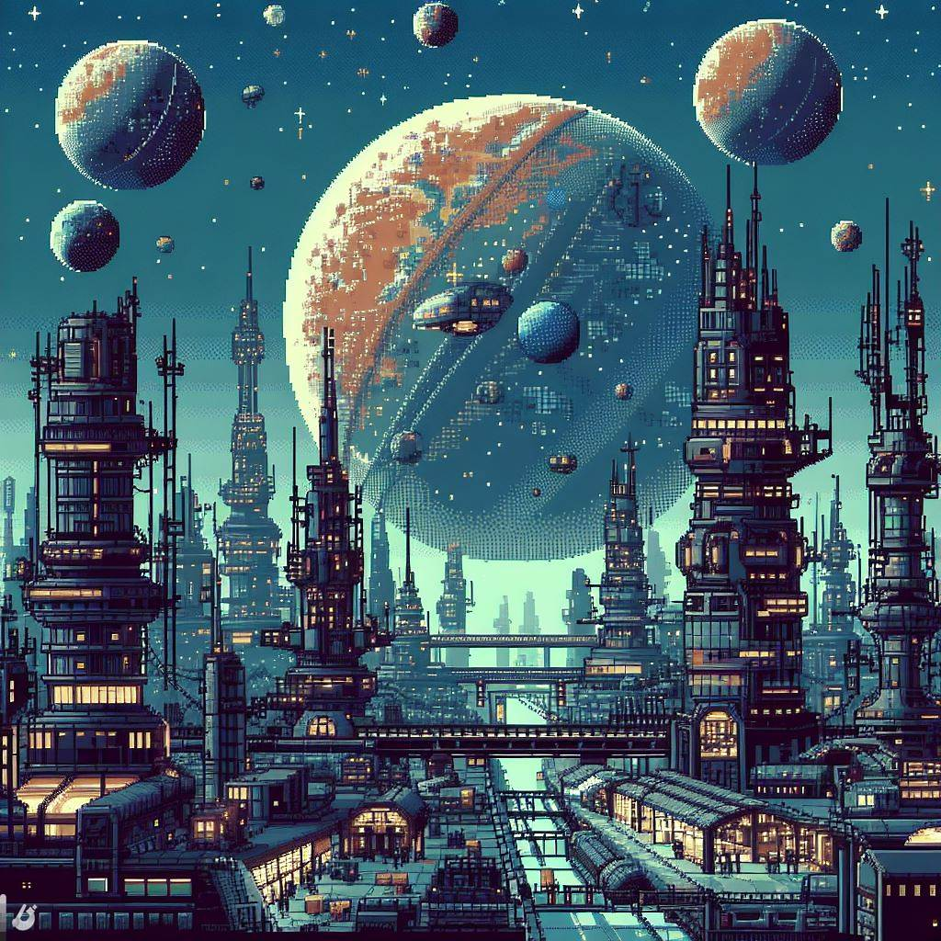

Figure 17 - Concept for The Heap, DALL E 3 (2023)

Wars in The Planes

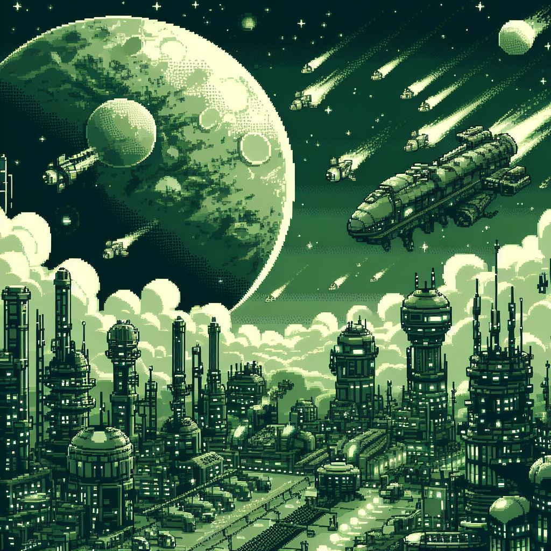

Figure 18 - Concept for The Planes, DALL E 3 (2023)

The abandoned worlds of The Beyond

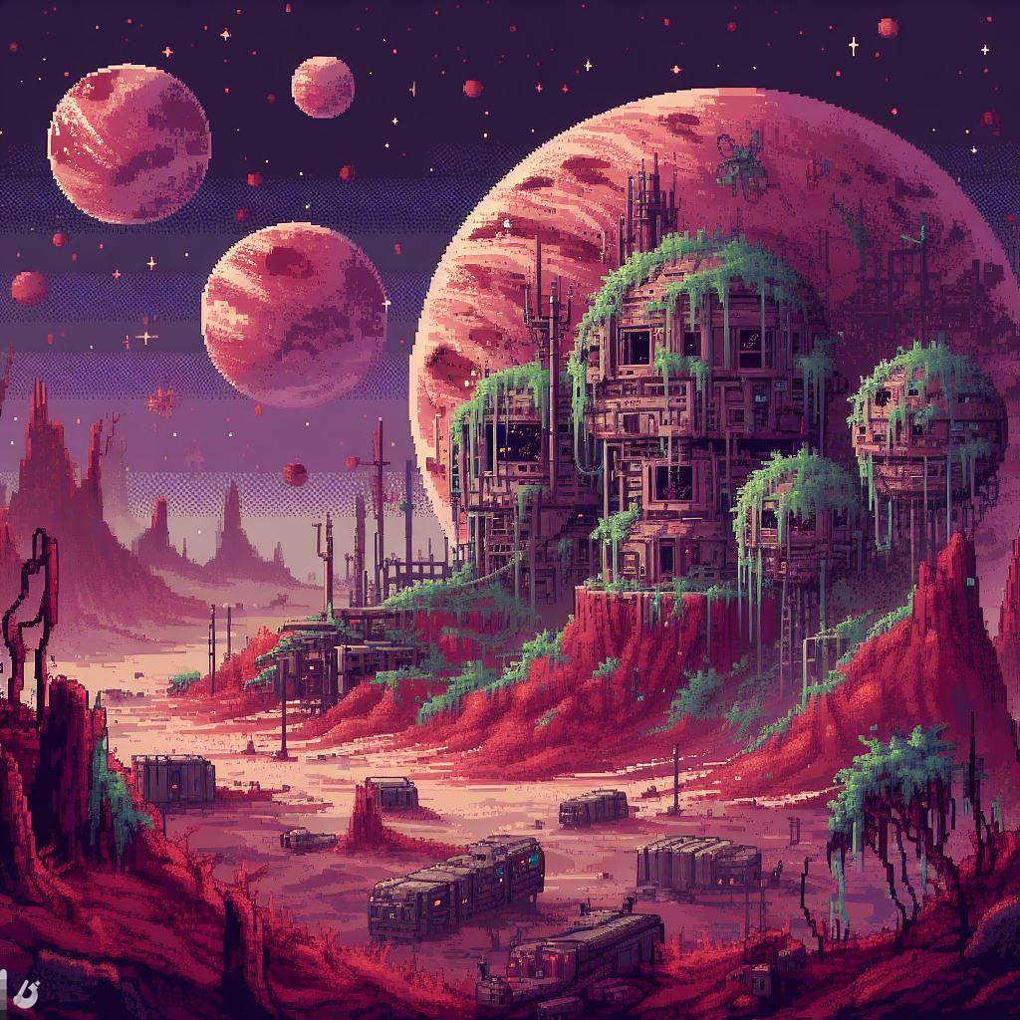

Figure 19 - Concept for The Beyond, DALL E 3 (2023)

Various ships and drones

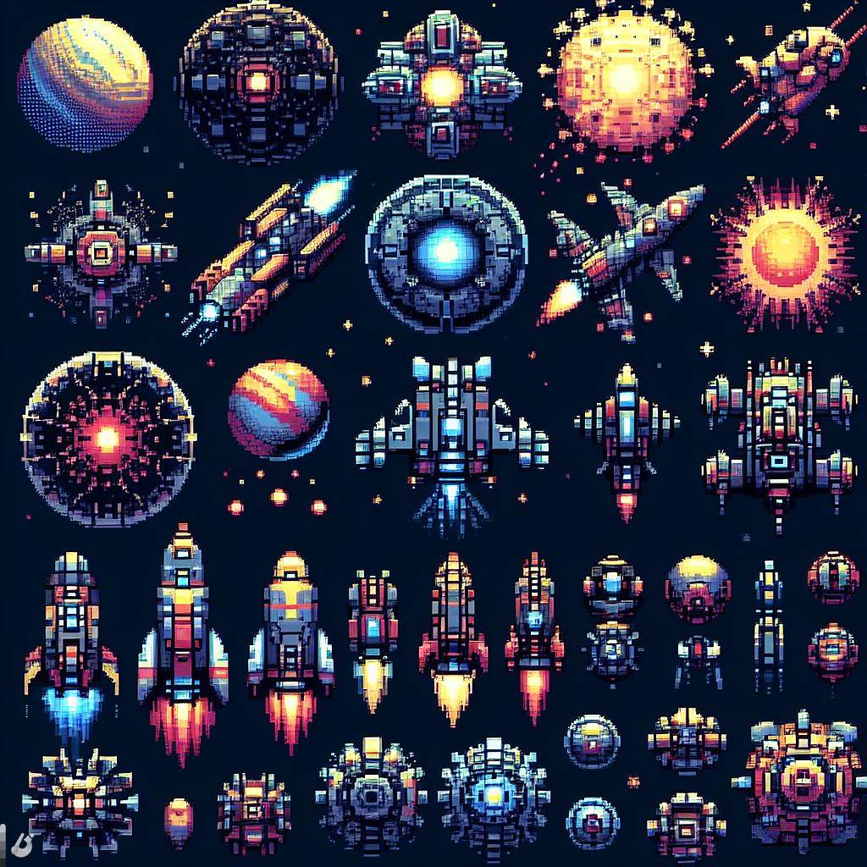

Figure 20 - Ship Concepts, DALL E 3 (2023)

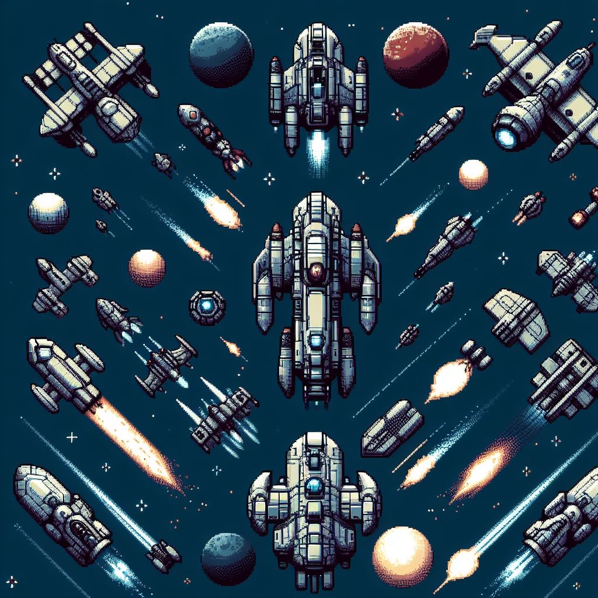

Figure 21 - Ship Concepts 2, DALL E 3 (2023)

Laser attack

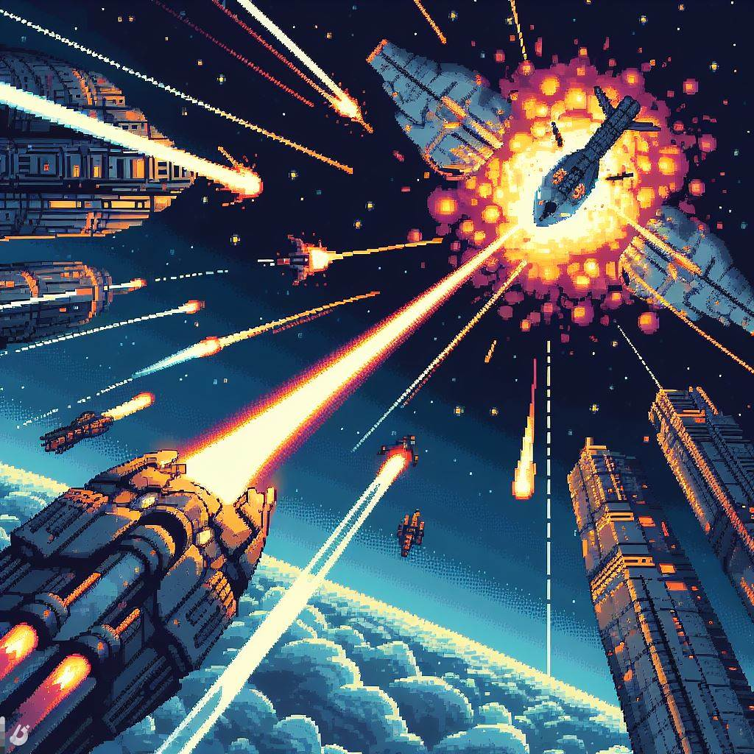

Figure 22 - Cinematic Attack Concept, DALL E 3 (2023)

Various icons for ships and upgrades

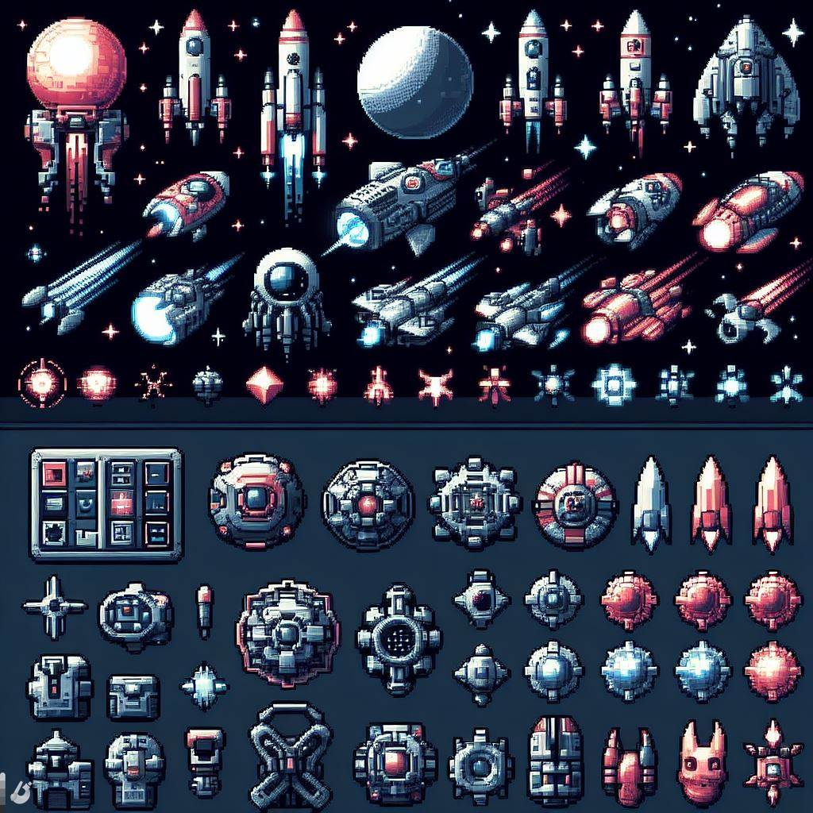

Figure 23 - Various Icon Concepts, DALL E 3 (2023)

# 5. Appendices

A short video demo of the games combat can be found here: <https://youtu.be/chqEr_pH8Wk>

## 5.1. Credits

Bing Image Creator, Dall E 3 (2023). *AI Generated Images:* <https://www.bing.com/images/create>

Manual+ (2022). *EDJO C203 Wireless Keyboard and Mouse Combo User Manual:* [https://manuals.plus/edjo/c203-wireless-keyboard-and-mouse-combo-manual#axzz7ooSoGFfG](https://manuals.plus/edjo/c203-wireless-keyboard-and-mouse-combo-manual%23axzz7ooSoGFfG)

Hopoo Games (2013). *Risk of Rain:* <https://store.steampowered.com/app/248820/Risk_of_Rain_2013/>

Mega Crit Games (2019). *Slay the Spire:* <https://store.steampowered.com/app/646570/Slay_the_Spire/>

## 5.2. References

Compton, C. (2019) *More than meets the eye: The secrets of dynamic difficulty adjustment*, *More Than Meets the Eye: The Secrets of Dynamic Difficulty Adjustment*. Available at: [https://www.gamedeveloper.com/design/more-than-meets-the-eye-the-secrets-of-dynamic-difficulty-adjustment](https://www.gamedeveloper.com/design/more-than-meets-the-eye-the-secrets-of-dynamic-difficulty-adjustment%20) [Accessed 19 Dec. 2023].

E., M. (2019) *A simple formula to creating a great turn-based RPG*, *Obilisk*. Available at: [https://www.obilisk.co/a-simple-formula-to-creating-a-great-turn-based-rpg/](https://www.obilisk.co/a-simple-formula-to-creating-a-great-turn-based-rpg/%20) [Accessed 10 Dec. 2023].

*Risk of rain 2 revenue* (no date) *Steam Revenue Calculator*. Available at: [https://steam-revenue-calculator.com/app/632360/risk-of-rain-2](https://steam-revenue-calculator.com/app/632360/risk-of-rain-2%20)

www.gamedeveloper.com. (n.d.). *After a worrisome start, Slay the Spire has sold more than 1.5 million copies*. [online] Available at: [https://www.gamedeveloper.com/business/after-a-worrisome-start-i-slay-the-spire-i-has-sold-more-than-1-5-million-copies](https://www.gamedeveloper.com/business/after-a-worrisome-start-i-slay-the-spire-i-has-sold-more-than-1-5-million-copies%20) [Accessed 21 Dec. 2023].

*SteamDB.* (n.d*.). Lifetime Concurrent Players on Steam.* Available at: <https://steamdb.info/app/646570/graphs/> [Accessed 22 Dec. 2023].

Koster, R. (2014). *A theory of fun for game design*. Sebastopol, Ca: O’reilly Media Inc.

Landsborough, D. (2017). *D. William Landsborough*. [online] D. William Landsborough. Available at: <https://www.dlandsborough.com/blog/2017/7/11/freytags-pyramid-and-the-three-act-plot-structure>.

Video Game Insights. (2021). *Video Game Insights - Games industry data and analysis*. [online] Available at: <https://vginsights.com/insights/article/how-to-estimate-steam-video-game-sales>.

Carless, S. (2020). *How that game sold on Steam, using the ‘NB number’.* [online] newsletter.gamediscover.co. Available at: <https://newsletter.gamediscover.co/p/how-that-game-sold-on-steam-using>.

Yu, D. and Gabe Durham (2016). *Spelunky*. Los Angeles, Ca: Boss Fight Books.

Gellel, A. and Sweetser, P. (2020). A Hybrid Approach to Procedural Generation of Roguelike Video Game Levels. International Conference on the Foundations of Digital